**Shoe Tying Methods**

**The one loop method: (refer to the picture below)**

* Make a cross
* Take the top lace under the cross and through the hole
* Make a loop in one lace
* Wrap the other lace around the loop and push some lace through the hole that is made at the bottom to make a second loop
* Pull both loops tight

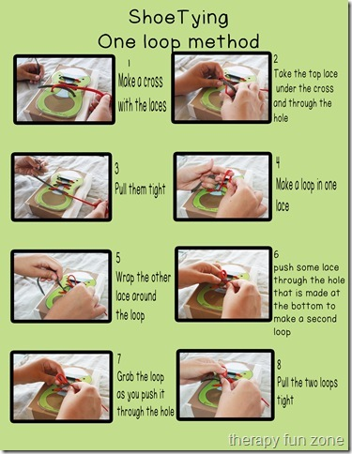

**The two loop method (bunny ears): (refer to the picture below)**

* Make a cross
* Take the top lace under the cross and through the hole
* Make a loop out of both laces
* Cross the loops
* Move the top loop under and through the hole
* Pull both loops tight

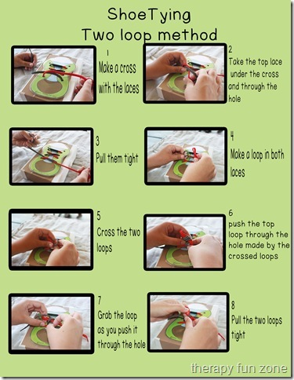

**Push and Tie (PAT) method: (refer to the picture below)**

This can be used as a last resort, or if a child is really young, but really wants to have success.

Check out this how-to video: <https://youtu.be/nXzOww2Ft48>

* Make a cross
* Take the top lace under the cross and through the hole
* Repeat the two steps above so that you have a loose knot
* Take the end of one lace and pass it back through the knot where it came out
* Do the same with the other lace
* Pull those laces so that your bow loops are the right size
* Pull the loops tight

